Learn how to use PI Web API to build modern applications - TechCon 2018

This course is a self-contained course to learn PI Web API and focuses on doing visualization. It will teach you how to extract data and search for attributes out of a PI System using PI Web API。This training also uses the Public PI Web API Endpoint and requires no PI software installed locally.

The training is in a Postman collection. Use the link below as a reference to install and run Postman: <https://www.getpostman.com/docs/postman/launching_postman/installation_and_updates>

Postman is a tool to test RESTful APIs and we use it to send requests against a PI Web API service. Those requests are grouped together in a Postman’s Collection, to import the collection into Postman, click the Import button on the top left and past in the link below.

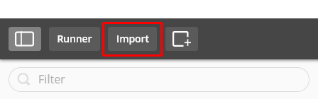

https://www.getpostman.com/collections/da2cadf6cbcce66f8adb

To get started with the training, simply select question 1 and expand the description to see the instructions to the exercise.

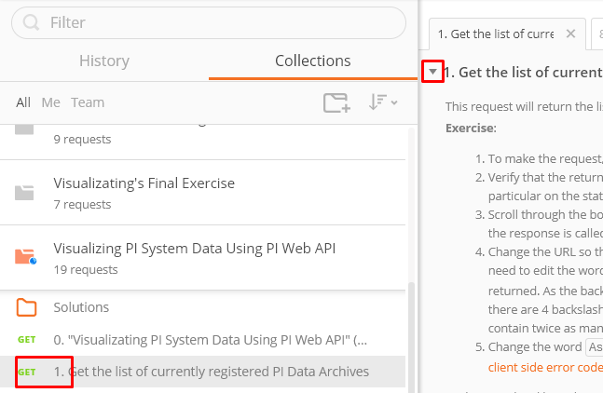

If you are new to PI Web API, select question 0 for a link introducing PI Web API to you.